Cybersecurity Incident Report:

Network Traffic Analysis

Review the scenario below. Then complete the step-by-step instructions.
You are a cybersecurity analyst working at a company that specializes in providing IT services for clients. Several customers of clients reported that they were not able to access the client company website www.yummyrecipesforme.com, and saw the error “destination port unreachable” after waiting for the page to load.
You are tasked with analyzing the situation and determining which network protocol was affected during this incident. To start, you attempt to visit the website and you also receive the error “destination port unreachable.” To troubleshoot the issue, you load your network analyzer tool, tcpdump, and attempt to load the webpage again. To load the webpage, your browser sends a query to a DNS server via the UDP protocol to retrieve the IP address for the website's domain name; this is part of the DNS protocol. Your browser then uses this IP address as the destination IP for sending an HTTPS request to the web server to display the webpage The analyzer shows that when you send UDP packets to the DNS server, you receive ICMP packets containing the error message: “udp port 53 unreachable.”
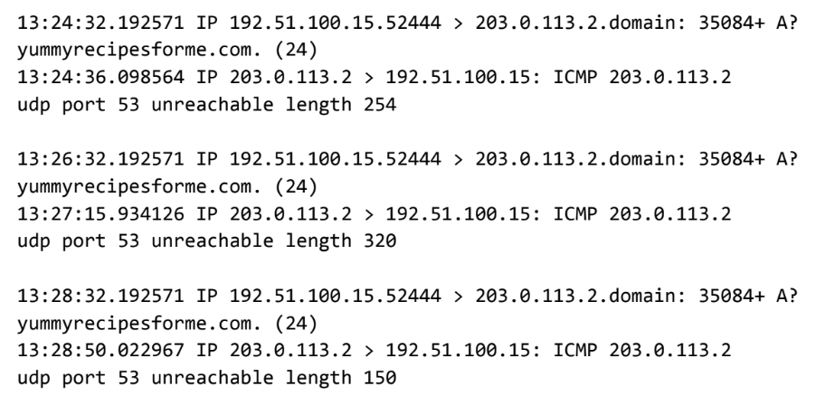
In the tcpdump log, you find the following information:
- The first two lines of the log file show the initial outgoing request from your computer to the DNS server requesting the IP address of yummyrecipesforme.com. This request is sent in a UDP packet.
- The third and fourth lines of the log show the response to your UDP packet. In this case, the ICMP 203.0.113.2 line is the start of the error message indicating that the UDP packet was undeliverable to port 53 of the DNS server.
- In front of each request and response, you find timestamps that indicate when the incident happened. In the log, this is the first sequence of numbers displayed: 13:24:32.192571. This means the time is 1:24 p.m., 32.192571 seconds.
- After the timestamps, you will find the source and destination IP addresses. In the first line, where the UDP packet travels from your browser to the DNS server, this information is displayed as: 192.51.100.15 > 203.0.113.2.domain. The IP address to the left of the greater than (>) symbol is the source address, which in this example is your computer’s IP address. The IP address to the right of the greater than (>) symbol is the destination IP address. In this case, it is the IP address for the DNS server: 203.0.113.2.domain. For the ICMP error response, the source address is 203.0.113.2 and the destination is your computers IP address 192.51.100.15.
- After the source and destination IP addresses, there can be a number of additional details like the protocol, port number of the source, and flags. In the first line of the error log, the query identification number appears as: 35084. The plus sign after the query identification number indicates there are flags associated with the UDP message. The "A?" indicates a flag associated with the DNS request for an A record, where an A record maps a domain name to an IP address. The third line displays the protocol of the response message to the browser: "ICMP," which is followed by an ICMP error message.
- The error message, "udp port 53 unreachable" is mentioned in the last line. Port 53 is a port for DNS service. The word "unreachable" in the message indicates the UDP message requesting an IP address for the domain "www.yummyrecipesforme.com" did not go through to the DNS server because no service was listening on the receiving DNS port.
- The remaining lines in the log indicate that ICMP packets were sent two more times, but the same delivery error was received both times.
Now that you have captured data packets using a network analyzer tool, it is your job to identify which network protocol and service were impacted by this incident. Then, you will need to write a follow-up report.
As an analyst, you can inspect network traffic and network data to determine what is causing network-related issues during cybersecurity incidents. Later in this course, you will demonstrate how to manage and resolve incidents. For now, you only need to analyze the situation.
This event, in the meantime, is being handled by security engineers after you and other analysts have reported the issue to your direct supervisor.

Part 1: Provide a summary of the problem found in the DNS and ICMP traffic log.

- The UDP protocol reveals that:

The network protocol analyzer logs indicate that port 53 is unreachable when attempting to access the client company website www.yummyrecipesforme.com.

Port 53 is typically used for DNS (Domain Name System), the protocol that translates human-readable domain names into IP addresses. This may indicate a number of problems, including: the DNS server is down not running or unreachable, the wrong DNS server is configured or is pointing to the incorrect DNS server IP, a firewall may be blocking UDP port 53 traffic, no network connectivity / no connection to the UDP server, DNS service is not running / DNS service is stopped on the server, The Internet Service Provider DNS server is having problems, or there is an incorrect network configuration including misconfigured gateway or subnets.

This could also indicate a DNS Denial of Service (DoS/DDoS) attack, a DNS Amplification attack, DNS Poisoning/Spoofing, DNS Hijacking, or a DNS tunneling attack.

- This is based on the results of the network analysis, which show that the ICMP echo reply returned the error message:

udp port 53 unreachable

- The port noted in the error message is used for:

Port 53 is used for DNS (Domain Name System) which translates human readable domain names into IP addresses.

- The most likely issue is:

The most likely issue is that the DNS service on the DNS server (port 53) is down or not running. This is indicated by the phrase “no service was listening.” This means the DNS server is reachable on the network but the DNS service itself has stopped running on port 53.

The most likely issue is that the DNS service on the server 203.0.113.2 has stopped running or crashed. This would prevent it from listening on port 53 and could be causing all DNS queries for www.yummyrecipesforme.com to fail. This would explain why no one can access the website.

Since we received a server reply with the ICMP error message “udp port 53 unreachable,” we know it's not a firewall issue, because if it were, the packets would have been dropped silently (the request would time out, or give no response).

Part 2: Explain your analysis of the data and provide at least one cause of the Incident.

- Time incident occurred:

The incident occurred at 12:24:32.192571 or roughly 1:24 PM and 32.192571 seconds.

- Explain how the IT team became aware of the incident:

The IT team became aware of this issue after several customers of the client, www.yummyrecipesforme.com, reported they were unable to access the client company website. They reported the error “destination port unreachable” after waiting for the page to load.

- Explain the actions taken by the IT department to investigate the incident:

The IT department received the customer complaints. IT analysts attempted to reproduce the issue by visiting the affected website. IT analysts received the same error, “destination port unreachable.”

IT analysts loaded network analysis tools, such as tcpdump, and captured network traffic while attempting to reload the webpage.

IT analysts analyzed the network traffic and identified key information from the log to determine which protocols were affected.

IT analysts then reported findings to supervisors so that the security engineers could handle the resolution.

- Note key findings of the IT department's investigation (i.e., details related to the port affected, DNS server, etc.):

At 1:24 p.m., 32.192571 seconds, IT analysts found that the client website www.yummyrecipesforme.com was unreachable by multiple customers. The error message they received was “destination port unreachable.”

IT analysts reproduced the issue and used tcpdump to capture and analyze network traffic to determine the cause.

The analysis revealed that the analyst’s computer (192.51.100.15) sent a UDP DNS query to the DNS server (203.0.113.2) on port 53 to resolve the domain name. The DNS server responded with an ICMP error message stating that “UDP port 53 unreachable.” This error was received consistently across three separate attempts, confirming the issue was not a one-time occurrence.

- Note a likely cause of the incident:

The likely cause of the incident was that the server's DNS service was not running on port 53 and no service was listening to handle incoming DNS queries. This prevented the website’s domain name from being resolved to an IP address, making the website completely inaccessible to all users.

